Essex Trophy

14th September 2019

Christchurch, Southgate – Middlesex County Association and London Diocesan Guild

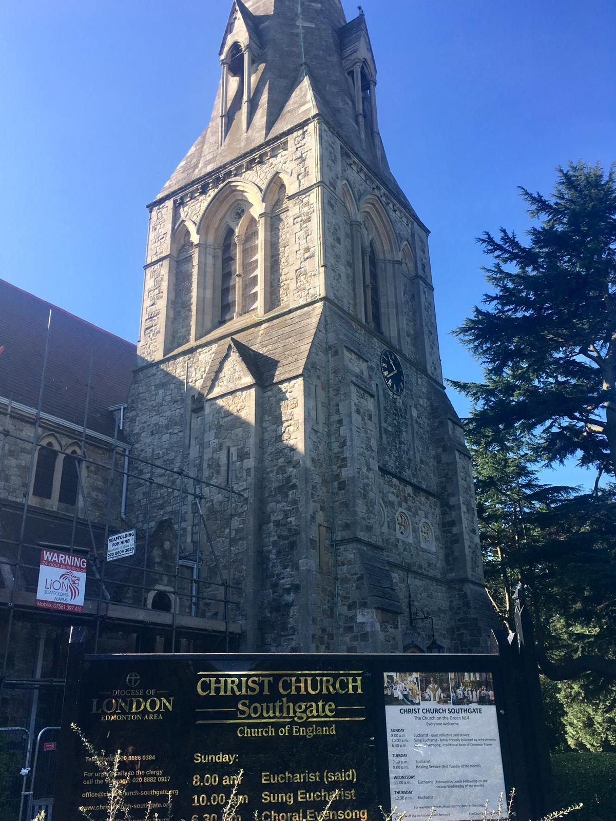

The Essex Trophy tell bell striking competition started in 1979 and has come to be an annual challenge for the Guilds and Associations which cover the south east of England. This year we met at Southgate in north east London on a bright and warm day to see who could strike Stedman Caters most accurately on these beautiful (but not necessarily easy) bells. After a flurry of advance requests for an early draw due to wedding commitments it turned out only one change was needed and this brought Surrey to the unenviable task of going first.
The judges explained that they had met ringing a peal at Southgate in 1984, Paul had tried to put Kate wrong in a peal (thinking he was putting her right) and she had corrected him in no uncertain terms. This is clearly a good recipe for lasting happiness as they married a year later and continue ringing together. They therefore had a memory of the bells and commented in the results that the 3, 4, 5 & 6 appear to be the most difficult to strike accurately.
Southgate bells are a Mears 8 which were augmented to 10 in 1920 and with a 25 cwt tenor sound excellent for the listeners in the church yard and the church hall (the pub garden was slightly too far away to hear the ringing so some people missed the later bands).
The touch was a composition from Lucy Woodward and the judges commented that the 2,3,4,5,6 runs were difficult for many teams. The combination of the bells and the composition sounded musical to the less trained ear but gave the judges an excellent opportunity to define a clear difference between the teams.

The results:
Kent 51
Guildford 68
Sussex 70
Essex 73
Surrey 75
Herts 86

Recognising the interest in statistics in these situations it is worth noting that the Sussex team was by far the youngest with 4 ringers under 21, that ringing first and last led to 5th and 6th place and that this year’s winners are next year’s hosts (although they didn’t know that when they volunteered to host for 2020). Perhaps most pertinently the slowest ringing won the competition with a peal speed of 3:27 vs. the fastest ringing in 6th place with a peal speed of 3:01.

The Essex Trophy is a complete model bell and suggestions to raise it above the head were (sensibly) rejected by the winner but the pride was clear to see.

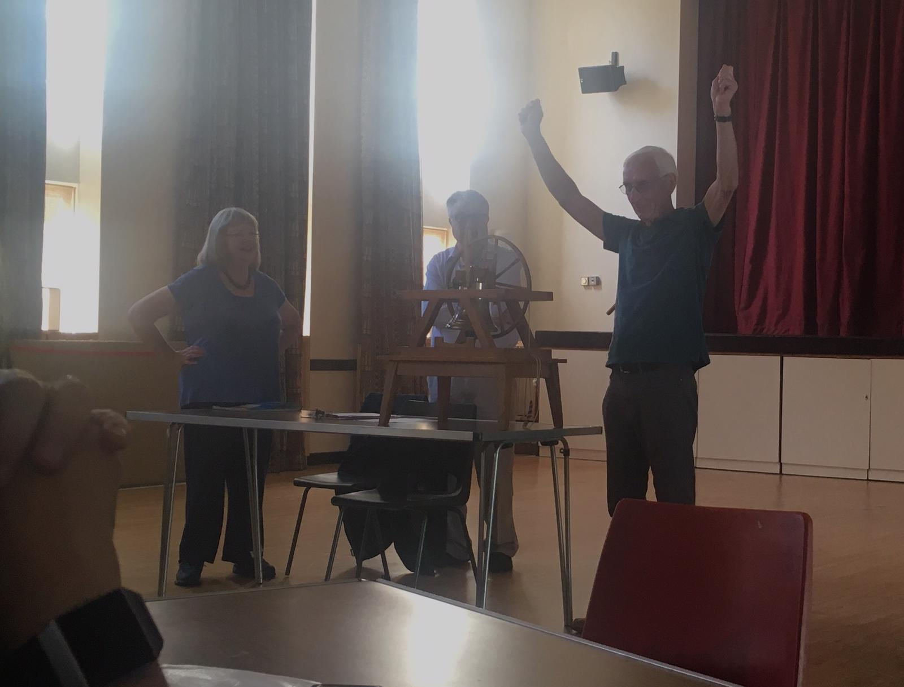

Thanks go to the Middlesex Association for hosting, particularly Martin Sutcliffe at Southgate, the Reverend Hazel Miall for welcoming us to Christchurch and our judges Kate and Paul Flavell.

Next year’s competition will be held on 12th September at St Mary the Virgin, Ashford, Kent with a test piece of Cambridge Royal.

The teams:

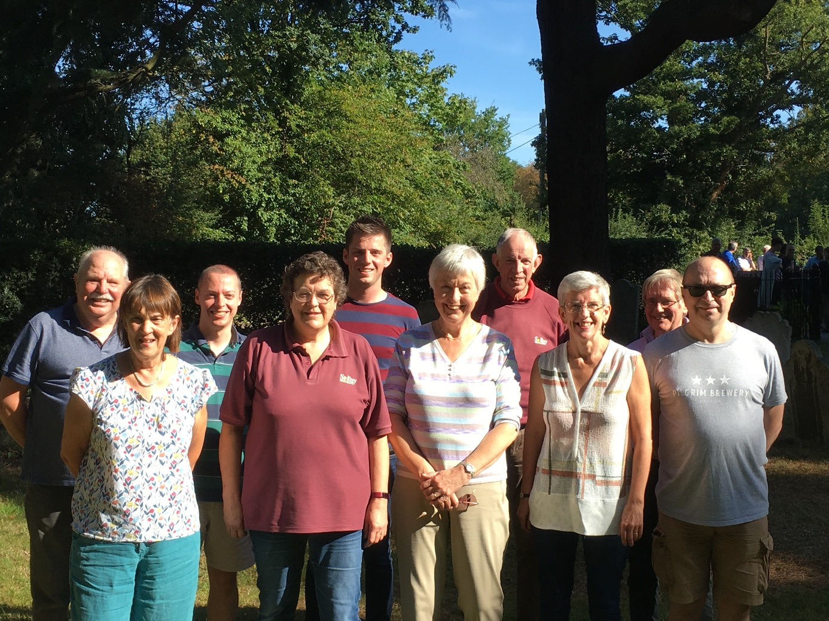

Surrey Association band (ringing 1 – 5 front row left to right and 6 – 10 back row left to right) Shirley McGill, Anne Rueff, Sheila Cheesman, Caroline Prescott, David Wallis, Michael Uphill ©, Tom Sibley, Phill Ridley, Jeremy Cheesman and Bob Cooles

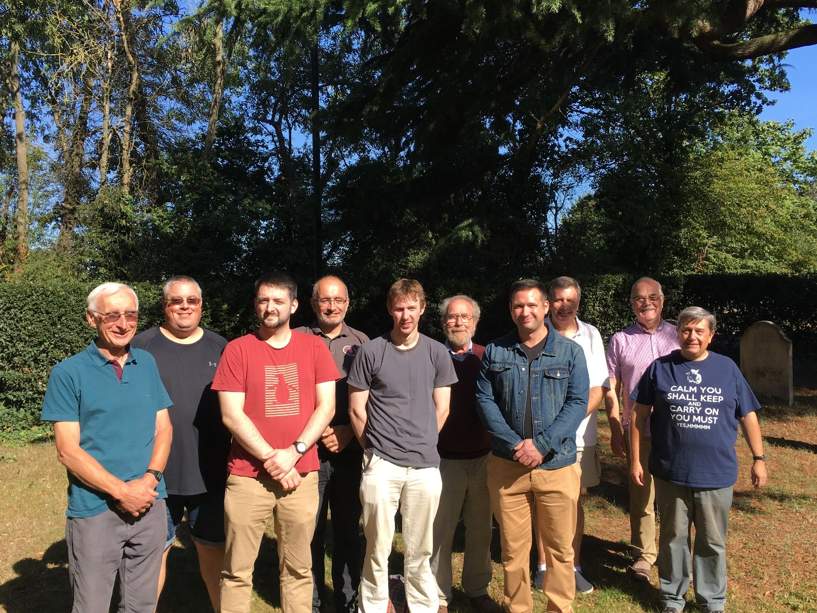

Kent County Association band (ringing 1 – 5 front row left to right and 6 – 10 back row left to right) David Hilling ©, Adam Brady, Andrew Hills, Mark Chittenden – Pile, Peter Swift, Douglas Davis, Neil Jones, Peter Joyce, Ian Mills and Colin Wyld

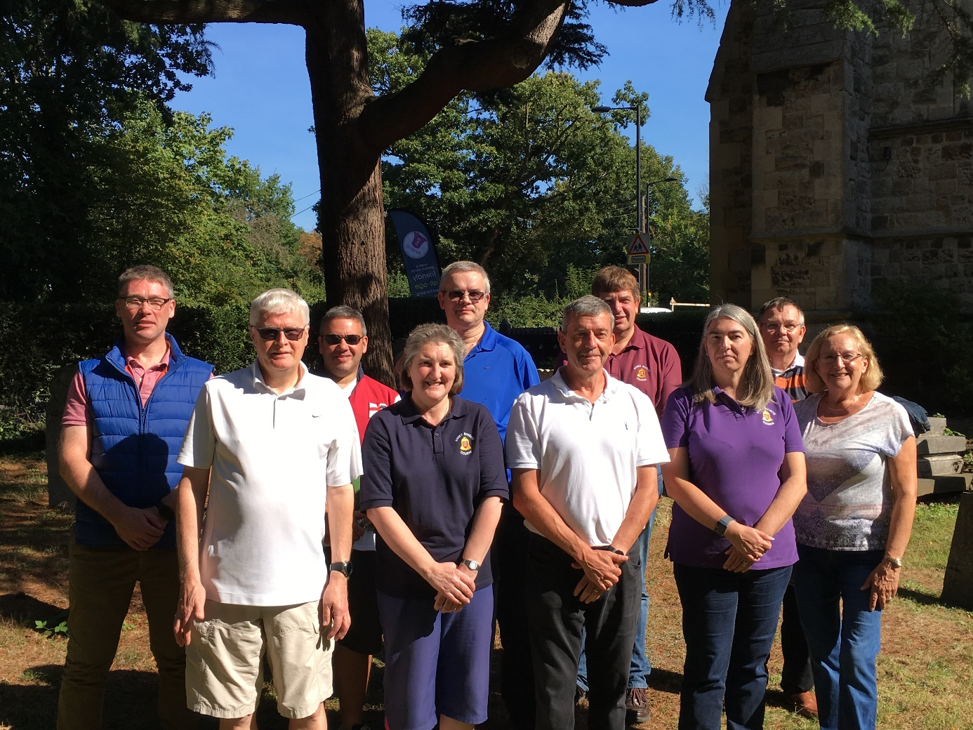

Essex Association band (ringing 1 – 5 front row left to right and 6 – 10 back row left to right) Paul Cammiade, Christina Brewster, David L Sparling, Vicki Chapman, Cecile Cross, Andrew Kelso, David M Hengeli, Stephen J Nash, Colin F Chapman © and Nigel SD Taylor

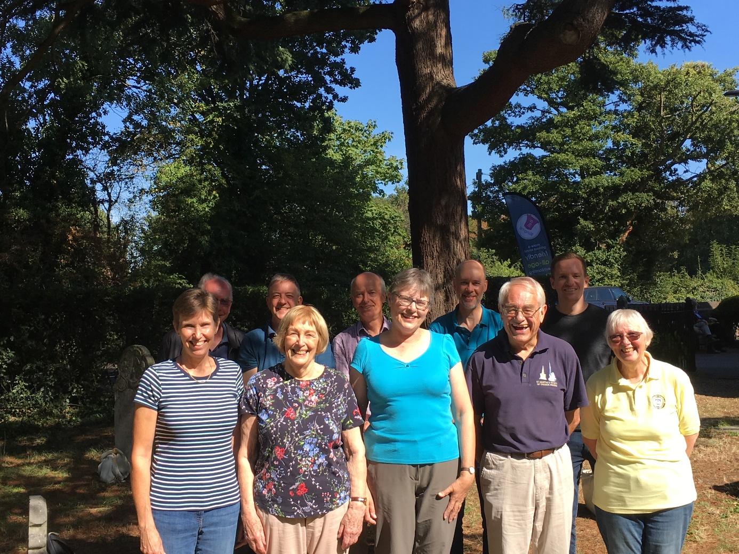

Guildford Diocesan Guild (ringing 1 – 5 front row left to right and 6 – 10 back row left to right) Elizabeth A Burton, Beryl R Norris, Anne M Anthony, Christopher H Rogers, Jackie Roberts, W John Couperthwaite, Richard H Burton ©, David R Beadman, Mark ER Gill and Matthew E Beadman

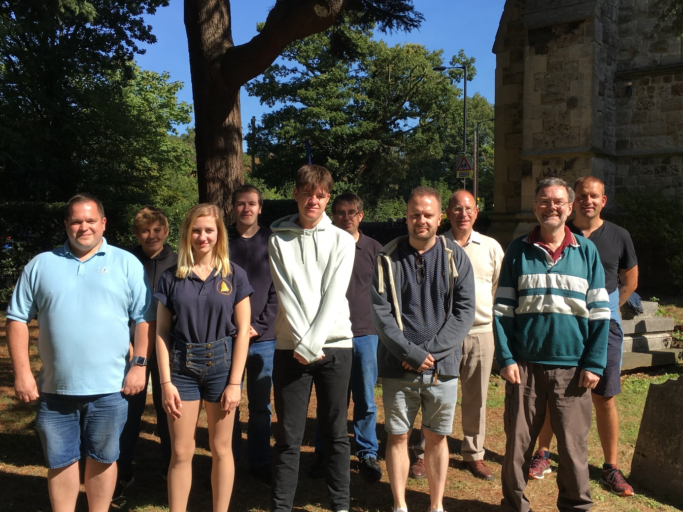

Sussex County Association (ringing 1 – 5 front row left to right and 6 – 10 back row left to right) Rob Lane, Rachel Mahoney, William Stafford, David Perkins, Simon Alford, Andrew Meyer, Andrew Alford, Stephen Beckingham ©, Simon Meyer and Jonathan Spencer
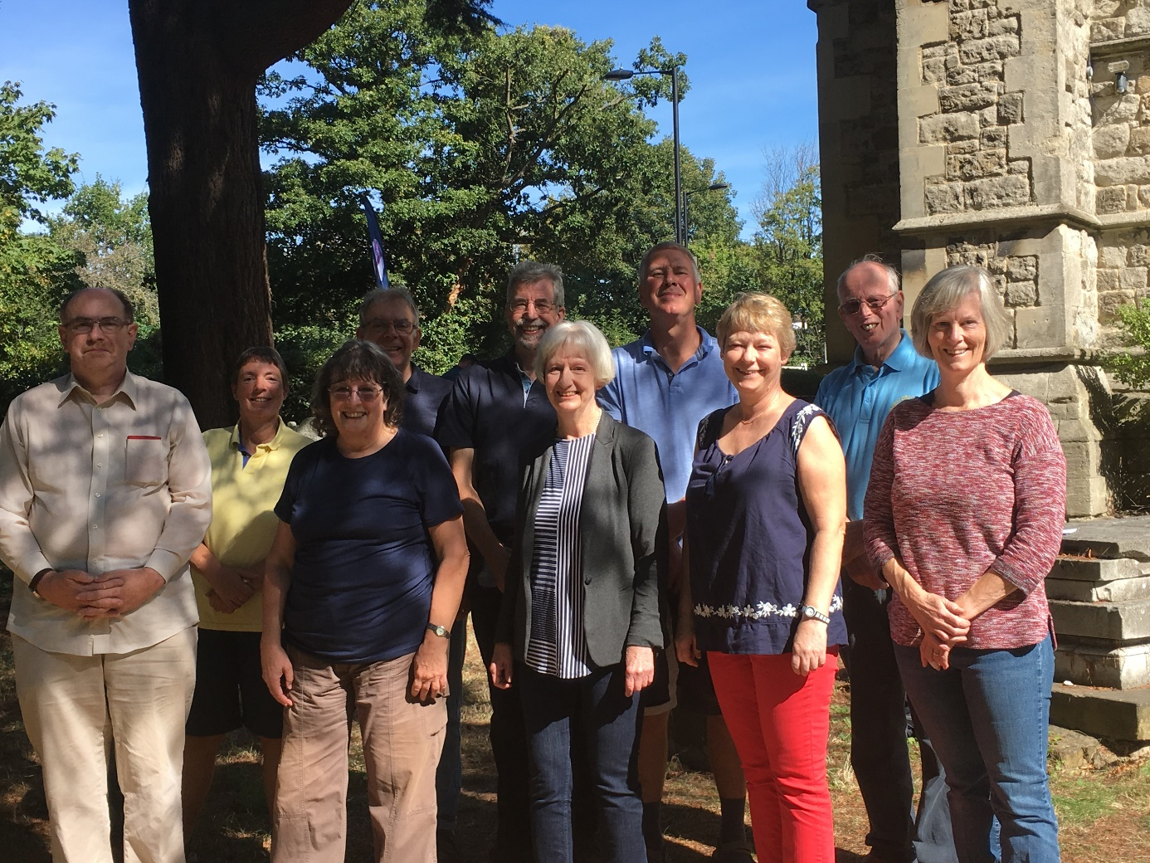

Hertford County Association band (ringing 1 – 5 front row left to right and 6 – 10 back row left to right) Owen Davis, Christine M Carter, Janet Penney, Julie Grimwade, Ann Evans, Rosemary E Sales, John R Peverett, Graham RD Lacy, Richard Sales © and Vivian Nutton

